Notice

All students and Faculty members are cordially invited to attend the following Programme:

Nature of Event: Seminar
Title of Event (if any): Dataristic (A Seminar on "Taking the step in the Data world")
Organising Body: Asankh – The Mathematics Society
Department: Mathematics Department
Date : 15th November 2022
Time: 12 Noon
Duration: 1 Hr
Venue: Seminar Hall
Link (if any): https://forms.gle/9ztKQnRtXKAc2jxw8
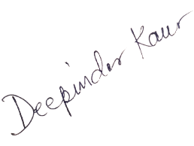
Signature:
Name: Mrs. Deepinder Kaur
(Convenor)

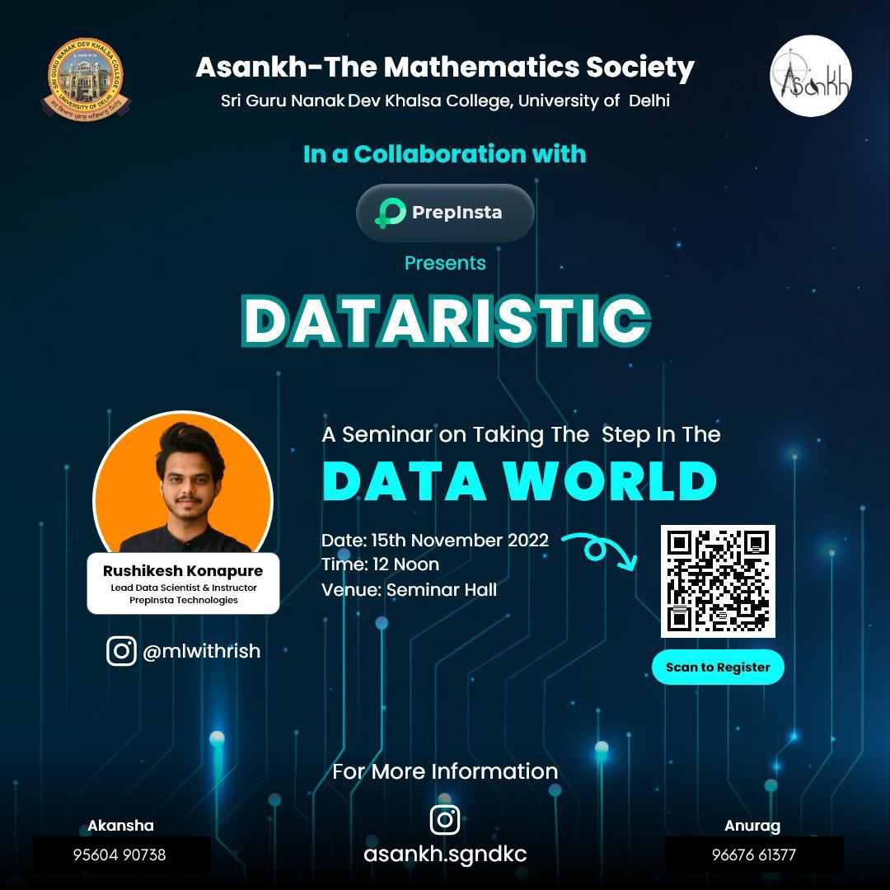

“Data isn’t information, information isn’t knowledge and knowledge isn’t wisdom.” – Lan Lowe

Greetings to everyone✨

*ASANKH* - The Mathematics Society of Sri Guru Nanak Dev Khalsa College, University of Delhi believes that without adequate _DATA_ many models would have absolutely no purpose!

In Collaboration with Prepinsta Technologies🫱‍🫲

Team ASANKH presents *”DATARISTIC”* ‍
A Seminar on Taking The Step In The _DATA WORLD_

*GUEST SEPAKER:*
*Mr. Rushikesh Konapure*
(Lead Data Scientist & Instructor
Prepinsta Technologies)

Look upon the details to be part of it :
Date :15th November,2022
Time : 12 Noon
Venue : Seminar Hall

*Register Now:*
https://forms.gle/9ztKQnRtXKAc2jxw8

*Join our whatsapp group*:
https://chat.whatsapp.com/DY1Pjhf3QlyEUOTjmgQV9A

For more details, Contact:
Akansha: 95604 90738
Anurag: 96676 61377

Looking forward to your presence.

Regards,
Team Asankh✨

