Sri Guru Nanak Dev Khalsa College
University of Delhi
National Service Scheme

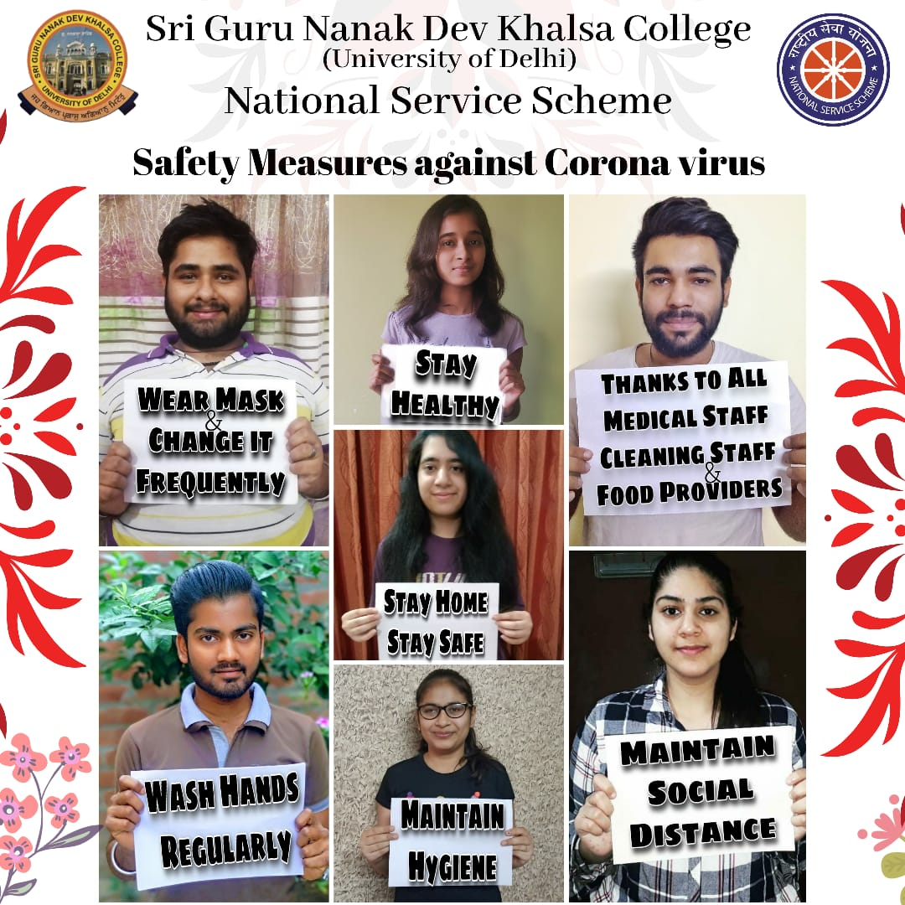

NSS unit of Sri Guru Nanak Dev Khalsa College, University of Delhi, in lockdown time due to spread of Covid19 took a step forward to aware the people about the Coronavirus through online method. Videography was used showing the steps to make a mask from home with use of cloth that is accessible to all the members of the family. Also, awareness through handmade posters was also done.

