Notice

All students and Faculty members are cordially invited to attend the following Programme:

Nature of Event: Inaugural and Treasure Hunt
Title of Event (if any): “The Inaugural Ceremony and Khoj: The Treasure Hunt”
Organising Body: Civil Society
Department: Political Science
Time: 12:00 pm
Duration: 2 hours
Venue: Gallery (Room no. 18)
Link (if any):

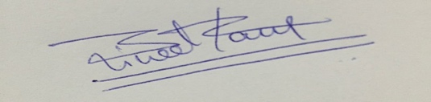
Signature:
Name: Dr. Bineet Kaur
(Convenor)
Civil Society

