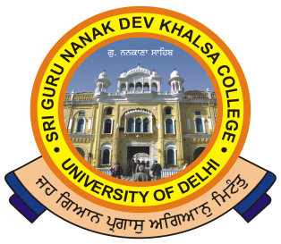 | SRI GURU NANAK DEV KHALSA COLLEGE  (UNIVERSITY OF DELHI)  NAAC Accredited B++  Dev Nagar, New Delhi-110005
Phone: 28729399 Fax: 011-28728909 E-mail: principal@sgndkc.du.ac.in

Ref. No._______ Dated: ___________

NOTICE

This is to inform to all the students that College has started e resources (ONLINE LEARNING SECTION) for this Lock down period under Covid-19.

Students are advice to please go through this.

(Dr. Gurmohinder Singh)
Oftg. Principal

