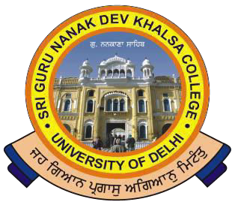
SRI GURU NANAK DEV KHALSA COLLEGE
(UNIVERSITY OFDELHI)
NAAC Accredited B++
Dev Nagar, New Delhi-110005.

Celebrating 550th Birthday Anniversary of Sri Guru Nanak Dev Ji

Ref. No. Dated 05/05/2022

Notice for Students regarding Examination Session May-June 2022

This is for the information that the students are required to report any mistake found in their admit card and get it corrected on 06/05/2022 by 3:00 p.m. in the College Office.

For any Clarification, contact in the College Office.

-sd- (Dr. Gurmohinder Singh)
Oftg. Principal

Phone : 28729399 Fax : 011-28728909 E-mail : principal@sgndkc.du.ac.in

