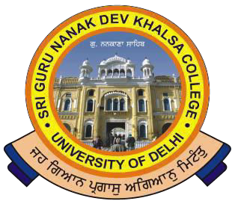SRI GURU NANAK DEV KHALSA COLLEGE
(UNIVERSITY OFDELHI)
NAAC Accredited B++
Dev Nagar, New Delhi-110005.

Celebrating 550th Birthday Anniversaryof Sri Guru Nanak Dev Ji

Ref. No. Dated 29/10/2021

Notice for Extension of Last Date of Second & Third Year Students Fee

College Fees by the students of II / III Yr. (All U.G. Courses) for the academic session (2021-2022) can be remitted through Online Mode only at the College website i.e., sgndkc.org –College Fee Portal All eligible Students are informed that the last date of online Fee Payment has been further extended up to 20th November, 2021, as per amount mentioned (Inclusive of Examination Fee but Excluding ER-Papers Exam. Fee) on the College Fee Portal.

*Fees paid by the Students if found "Not eligible" as per Notifications received from the University Later... will be refunded back.

For any Clarification, contact in the College Office.

-sd- (Dr. Gurmohinder Singh)
Oftg. Principal

Phone : 28729399 Fax : 011-28728909 E-mail : principal@sgndkc.du.ac.in

