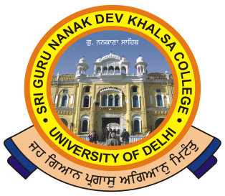 | SRI GURU NANAK DEV KHALSA COLLEGE  (UNIVERSITY OF DELHI)  NAAC Accredited B++  Dev Nagar, New Delhi-110005
Phone: 28729399 Fax: 011-28728909 E-mail: principal@sgndkc.du.ac.in
Ref. No._______ Dated: ___________
UNDER-GRADUATE ADMISSIONS (MERIT BASED)
2020-2021
SEVENTH CUT OFF LIST - PERCENTAGE
SNO | COURSE | GENERAL | SIKH MINORITY | PwD | KASHMIRI MIGRANT
1 | B.Com | 90 | 77 | 59 | 80
2 | B.Com (Hons.) | 92.5 | 79 | 60 | 82.5
3 | B.A. (Hons.) English | Closed | 80 | 65 | 80.5
4 | B.A. (Hons.) Hindi | Closed | 50 | 60 | 70
5 | B.A. (Hons.) Hindi Patrikarita | Closed | 55 | 58 | 68
6 | B.A. (Hons.) History | Closed | Closed | 58 | 76.75
7 | B.Sc (Hons.) Mathematics | 85 | 67 | 55 | 75
8 | B.A. (Hons.) Political Science | Closed | 70 | 58 | 80
9 | B.A. (Hons.) Punjabi | 45 | 45 | 45 | 45
10 | B.A Programme (English + Economics) | 89.5 | 75 | 57 | 79.5
11 | B.A Programme (English + Political Science) | 89 | 75 | Closed | 79
12 | B.A Programme (Punjabi + Economics) | 80 | 75 | 57 | 70
13 | B.A Programme (Punjabi + History) | 79 | 72 | 57 | 69
14 | B.A Programme (Economics + Mathematics) | Closed | 75 | 57 | 78.5
15 | B.A Programme (Economics + Political Science) | Closed | 75 | 57 | 80
16 | B.A Programme (History + Political Science) | 88 | 68 | Closed | 78
17 | B.A Programme (Mathematics + Political Science) | Closed | 70 | 57 | 77.00
* The combination of two discipline subjects and seats allocation is subject to change at discretion of College.
Advantages and disadvantages as per University Norms.
Admissions from 7th December 2020 to 9th December, 2020 & Payment upto 10th December 2020 11:59 p.m. on all working days except Sunday and holidays.
Students Eligible Under any of Earlier Cutoff will Not be Eligible

(CA A. P. Singh Arora) |  |  |  | (Dr. Gurmohinder Singh)
Convenor, Admission Committee |  |  |  | Oftg. Principal

