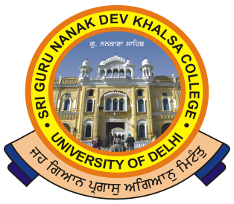

SRI GURU NANAK DEV KHALSA COLLEGE
(UNIVERSITY OF DELHI)
Dev Nagar, New Delhi-110005.
Phone : 28729399 Fax : 011-28728909 E-mail : principal@sgndkc.du.ac.in
___________________________________________________________

Ref. No._______ Dated:-02/09/2019

NOTICE
This is to inform that a 30 hours Short-term Add-on Course (ASCC-19) on “Adaptation Studies” is being organized by the Department of English. The course is open for all the students of English Honours but the number of seats for the course are limited to 15. Eligibility for the course will be decided on the basis of students’ performance in the workshop English for the Purpose of Research (ELPR-19). The course will be inaugurated on 4th September 2019 and will be over by 22nd October 2019. Course fee for the workshop is Rs. 1499/- and the registration in the course will be considered final only after the paying of the fee.

Dr. Abhishek Sharma Dr. Gurmohinder Singh
(Convenor) (Oftg. Principal)

