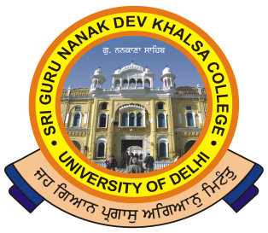 | SRI GURU NANAK DEV KHALSA COLLEGE  (UNIVERSITY OF DELHI)  NAAC Accredited B++  Dev Nagar, New Delhi-110005
Phone: 28729399 Fax: 011-28728909 E-mail: principal@sgndkc.du.ac.in

Ref. No._______ Dated: ___________

Dear Colleagues,
In these troubled times faced by humanity, it is very natural to feel anxious and depressed. The lockdown is impacting the mental well being of most of us. SRI GURU NANAK DEV KHALSA COLLEGE wants to go an extra mile and help all the students who are encountering emotions of stress, depression and anxiety . The college has constituted an online counselling centre wherein the counsellors can be telephonically contacted to extend psychological support to students . The students are assured of strict confidentiality.

Dr. Gita Lakhanpal 9891239070
Dr. Chopra 9868366578(Medical Practitioner)
Dr. Jasmine Lamba 9811160007
Mrs. Meera Dhiri 9810488047 (Oftg. Admin Officer)

All the colleagues can share the contact details of above Counsellors with their students.

Stay Safe

(Dr. Gurmohinder Singh)
Oftg. Principal

