Sri Guru Nanak Dev Khalsa College
University of Delhi
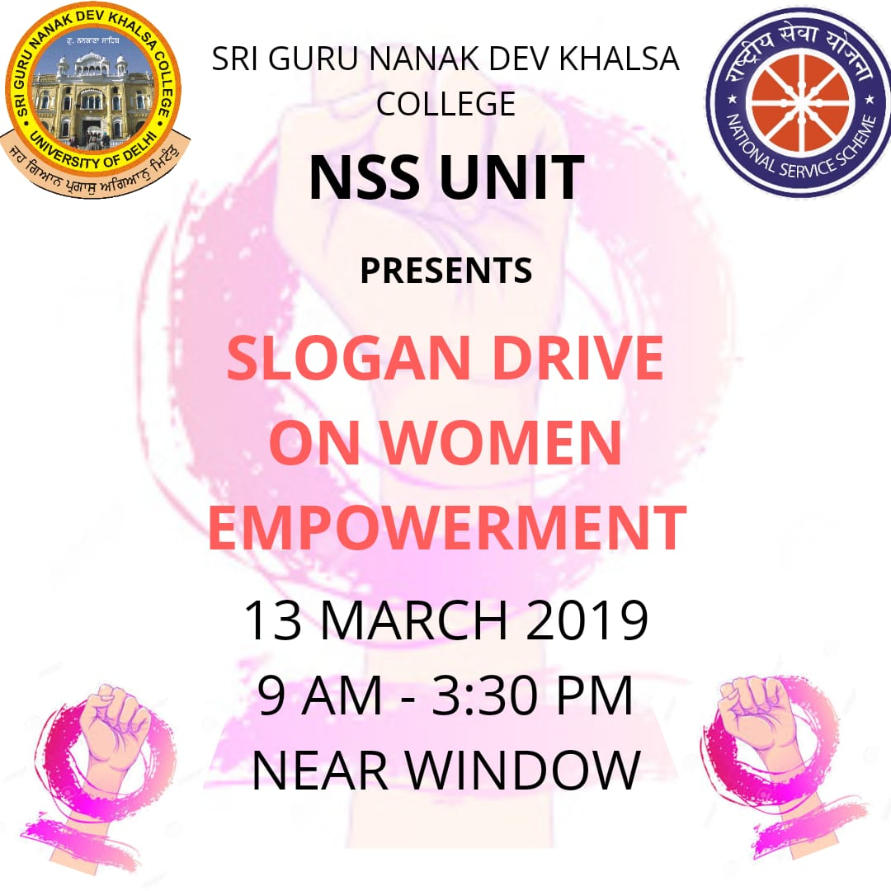
Slogan Drive on Women Empowerment
13 March 2019
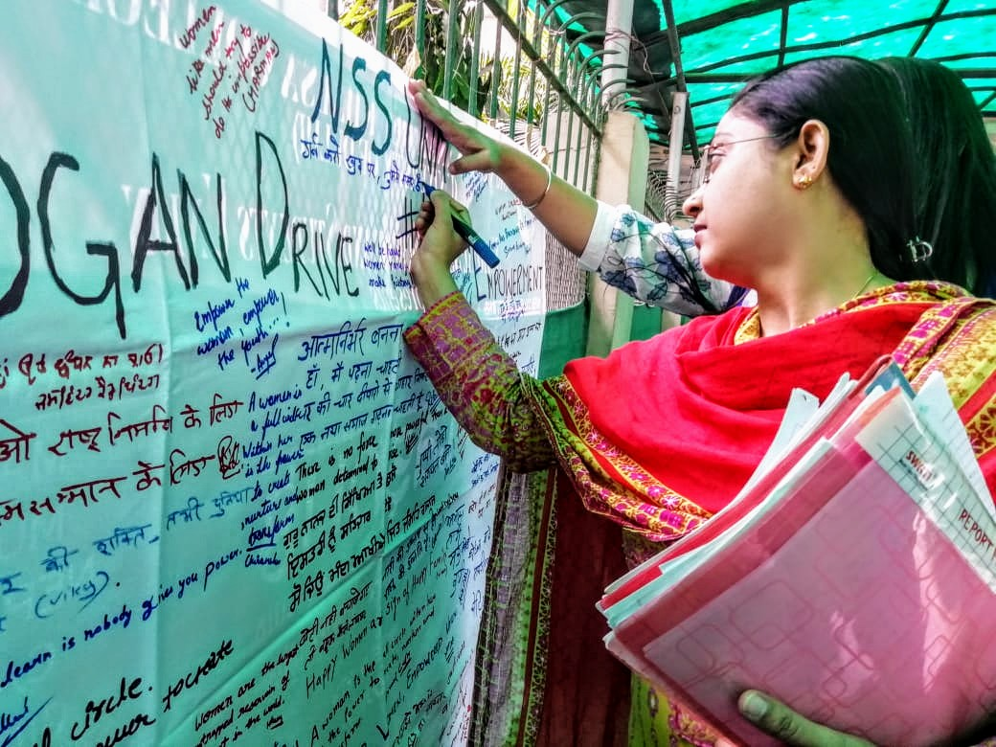
NSS unit of Sri Guru Nanak Dev Khalsa College University of Delhi organised Slogan Drive on Women Empowerment on 13th March 2019. Students wrote their slogans on the flex in the college campus. All volunteers and the studens also learned about importance and Dignity of women's position in society. The drive held between 09:00 A.M. - 3:30 P.M.


